 

**Arab Academy for Science, Technology and Maritime Transport. College of computing and information technology.**

**Structure of Programming (CS445)**

**Music Player**

**Team Members:**

* Ali Salamouny 19107921
* Habiba Amr 19107385
* Nada Mohamed 19107229
* Zeiad Ahmed 19107161

**Lecturer: Dr.** Sherif Morsy

**T.A: Eng.** Ali Zeen ElDin

**Description:**

- Everybody loves listening to music wouldn’t it be cool to have our very own mp3 music player. So, in this python project, we are going to create an mp3 player with the help of python and its libraries. We will create an mp3 music player in which we can play the song, pause it, resume it, and navigate from the current song to the next song as well as previous songs.

**Libraries:**

**- Time:** Python has a module named time to handle time-related tasks

**- Pygame:** Cross-platform set of Python modules that are used to create video games. It consists of computer graphics and sound libraries designed to be used with the Python programming language.

**- Tkinter:** Creating a GUI application

**- filedialog:** You can open a single file, a directory, save as file and much more

- **mutagen.mp3:** Mutagen is a Python module to handle audio metadata. It supports all audio files

**- tkinter.ttk:** provides access to the Tk themed widget set

**Functions:**

* **Play_Time():** get the time of the sound and when you move the slider the time changes also.

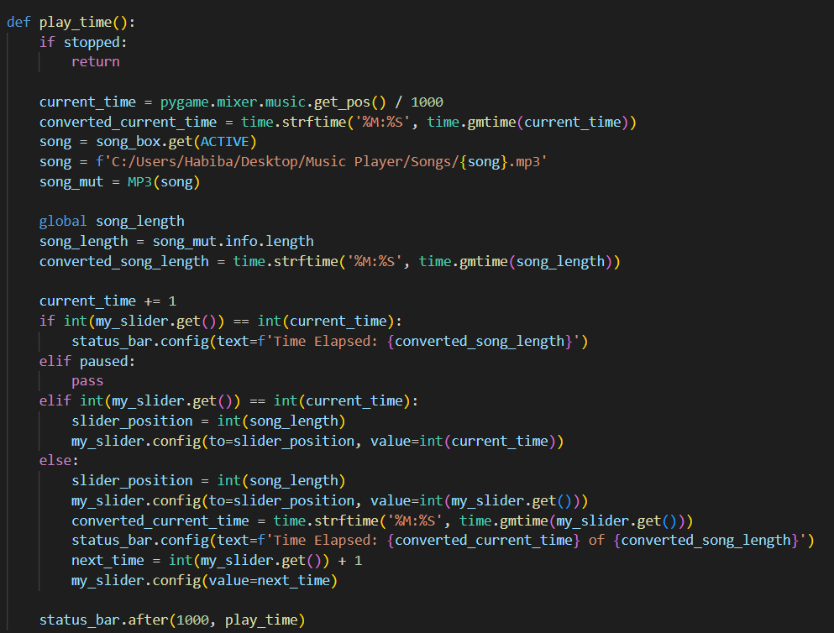

* **Add_Song():** add song in the list.

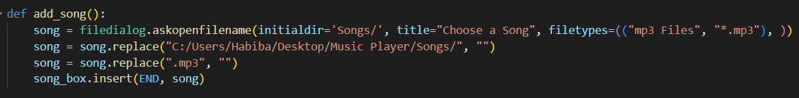

* **Add_Many_Songs():** add many songs in the list.

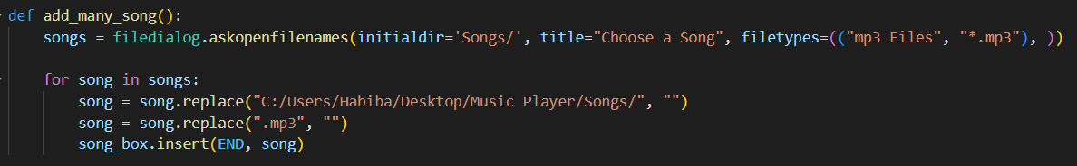

* **Delete_Song():** delete one song from the list.

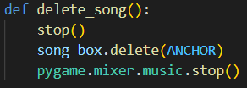

* **Delete_All_Songs():** delete all the songs from the list.

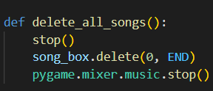

* **Play():** play the song.

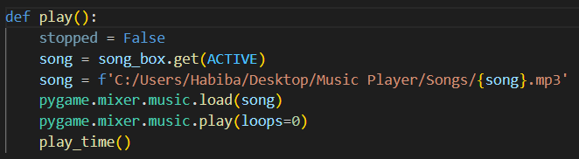

* **Back():** go to the song before.

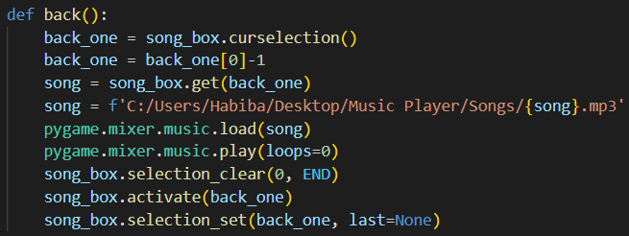

* **Next():** go to the song after.

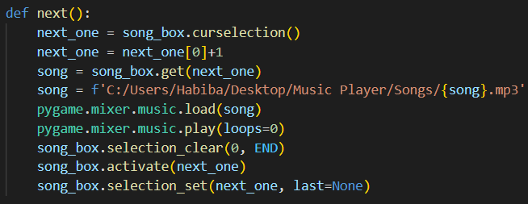

* **Pause():** pause the song.

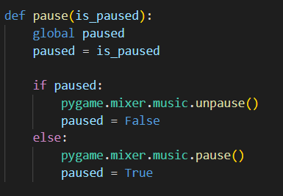

* **Stop():** stop the song.

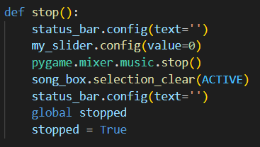

* **Slider():** slider to move the song to specific minute.

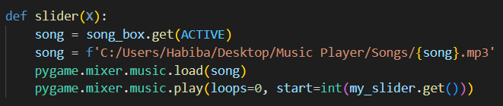

* **Volume():** slider to volume up and volume down sound.

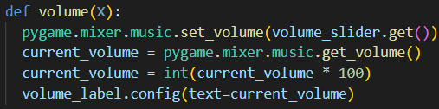

**GUI:**

